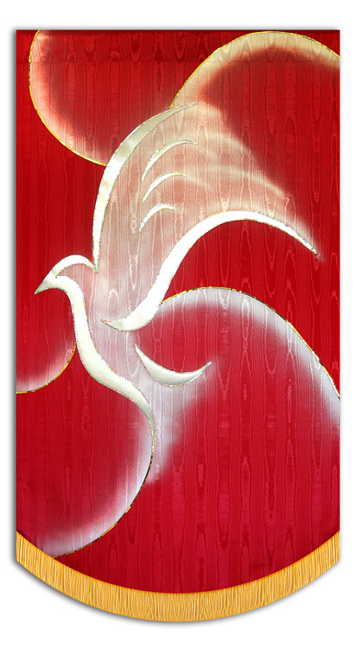
-
Confirmation
2019

Name of Church

Date & Month 2019

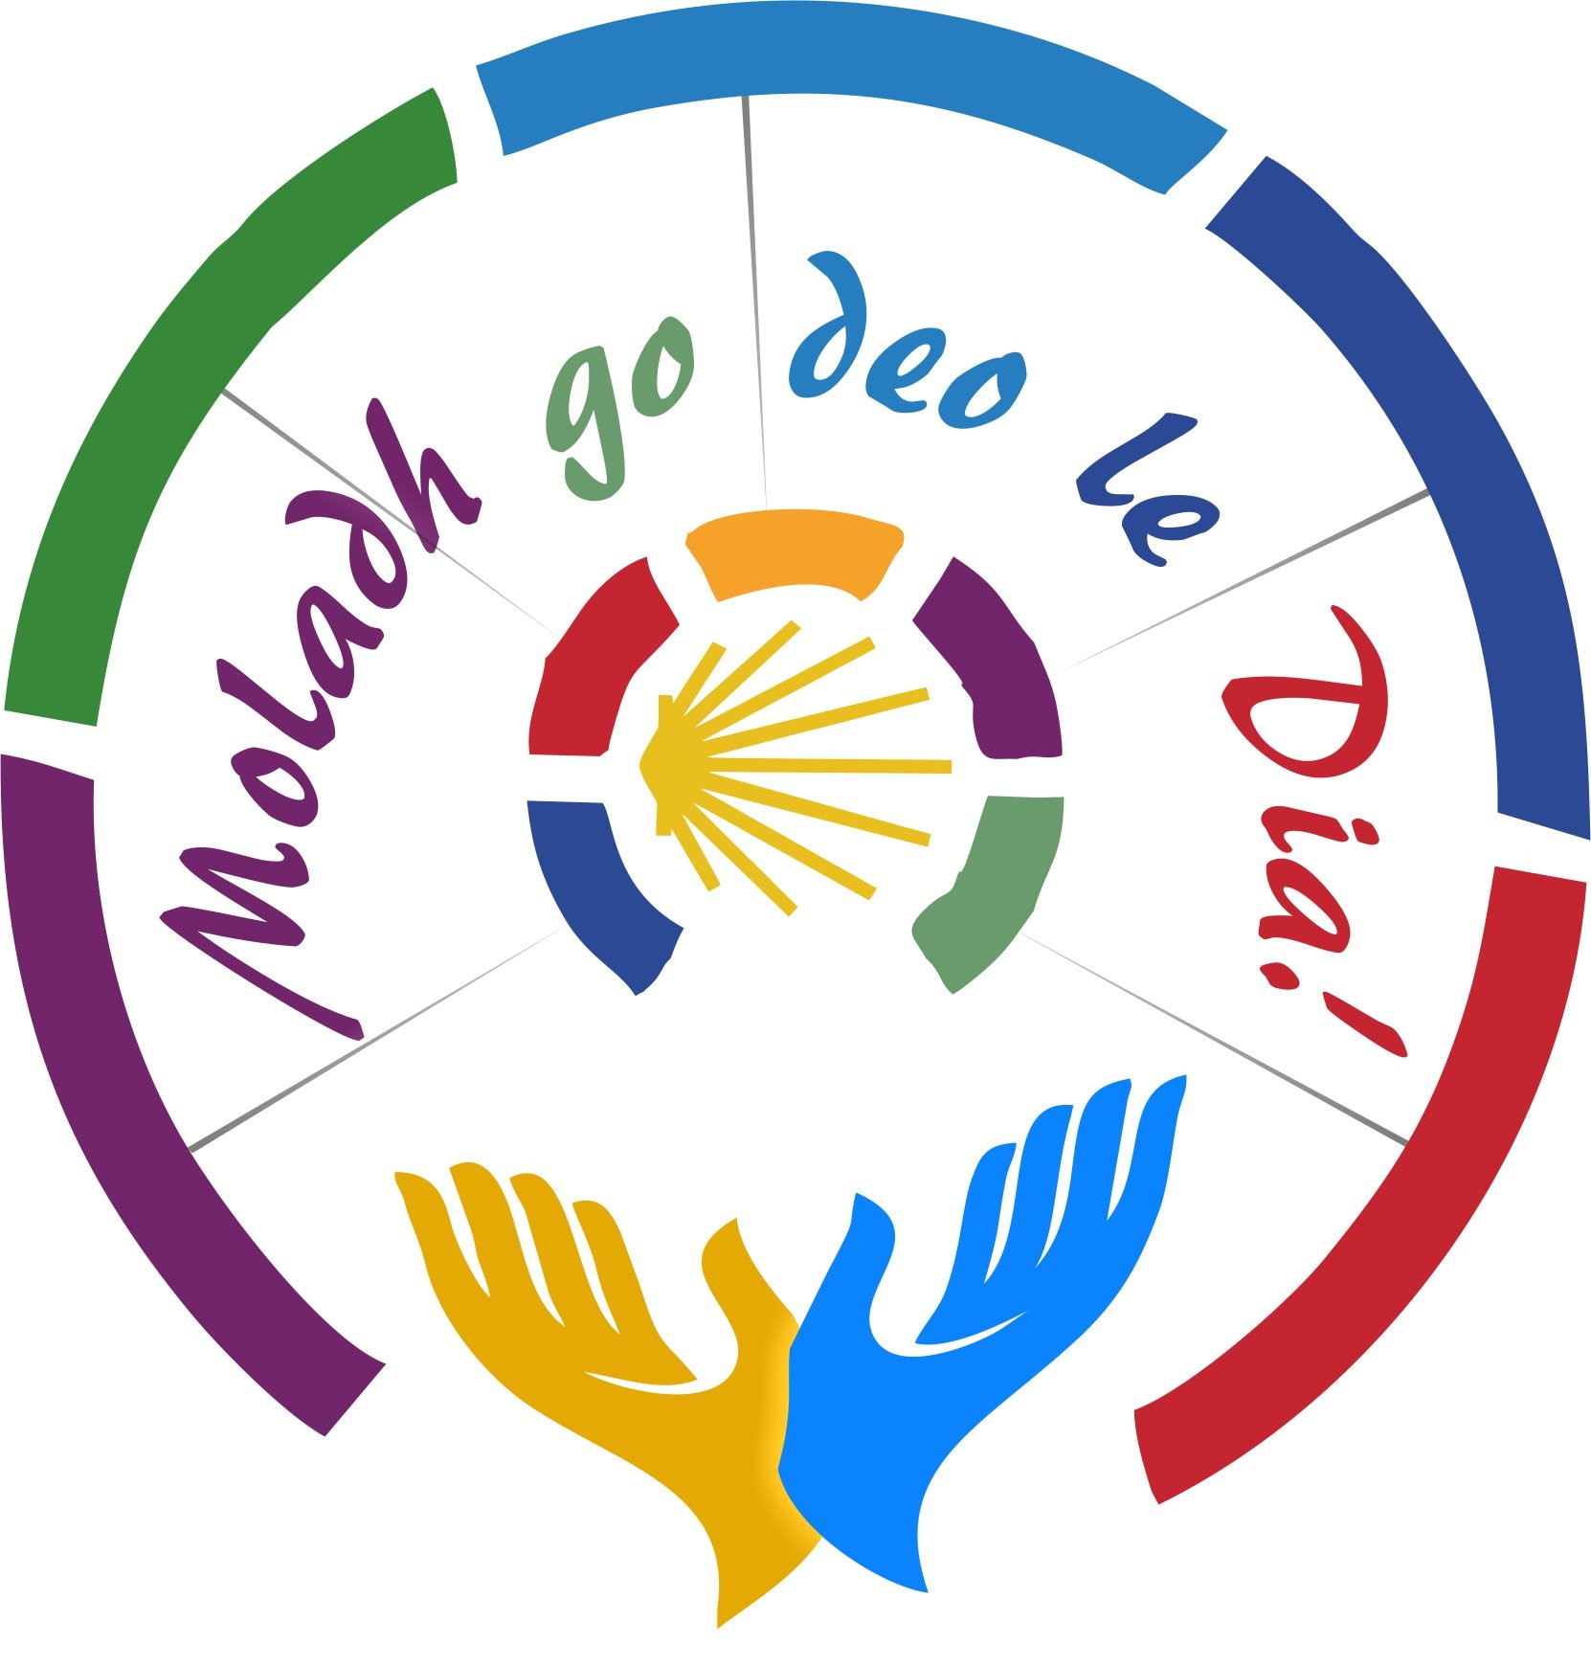
Celebrant:
Bp. Fintan Monahan
Bishop of Killaloe
The Gathering Rite
It is appropriate for a representative of the Parish Community (Chair/Member of the Parish Pastoral Council) to welcome those who have gathered.
They might use these or similar words:

Words of Welcome
On behalf of the faith community in the parish of (Name of Parish), I welcome you all here today as we rejoice in the gifts of the Spirit that are given to us to help build up God’s Kingdom. I warmly welcome Bishop Fintan, the young people who will receive the Sacrament of Confirmation along with their families, friends and visitors who have come to share in this special day on their journey of faith. Today these young people will commit to living the Christian way of life and they will receive the Holy Spirit to help them in that mission. Our parish rejoices as they are confirmed in the faith of their Baptism, the faith of this community, the faith of the Church.

I now invite you to stand for the procession and to join in our Gathering Hymn:
(Name of Opening Hymn here).

Bishop Fintan: In ainm an Athar…
All: Amen
Bishop Fintan Peace be with you
All: And with your Spirit.

Bishop Fintan says some words of welcome and then invites everyone to sit for the Procession of Symbols.

The Procession of Symbols

Reader(s):

Today we gather to celebrate the Spirit of Jesus within each of us, and to confirm our young adults in the gifts of the Spirit - gifts they have already received at baptism. Today we ask God to confirm these gifts of his love and grace in our young people. We pray too that they will be drawn into a real sense of belonging in our parish community. We begin our celebration by presenting symbols of the Spirit’s gifts.
1________ brings the symbol of Wisdom. The Spirit’s gift of Wisdom will help us to have a deep understanding of God, and God’s ways, and to value the things of God. (The symbol is placed in the Sacred Space)

2________ brings the symbol of Understanding. The Spirit’s gift of Understanding helps us to look at people and situations in the way Jesus looks at them. It helps us to know God better
(The symbol is placed in the Sacred Space)

3________ brings the symbol of Right Judgement. The Spirit’s gift of Right Judgement will inspire and guide us to make good decisions.
(The symbol is placed in the Sacred Space)

4________ brings the symbol of Courage. The Spirit’s gift of Courage will help us to accept the challenge of living the way of Jesus. We need the Spirits help to stand out from the crowd as a young person to be a follower of Jesus today. The symbol is placed in the Sacred Space).

5________ brings the symbol of Knowledge. The Spirit’s Gift of Knowledge helps us to see God in everything, in the people around us and in the world in which we live. We ask for this gift because it will help us to think and act differently.
(The symbol is placed in the Sacred Space)

6 ________ brings the symbol of Wonder and Awe. The Spirit’s gif of Wonder and Awe helps us to be aware of the greatness of our God and to see God’s glory in the world around us. It will make us aware in a special way of the wonder of creation and help us to work to take care of it. (The symbol is placed in the Sacred Space)

7________ brings the symbol of Reverence. The Spirit’s gift of reverence helps us to honour and give thanks to God. If we do this, we will learn also to honour and respect each person we meet because they are created in the image and likeness of God. (The symbol is placed in the Sacred Space)

Penitential Rite:

Bishop Fintan:
Pope Francis says that families come in all sorts of shapes and sizes and no family is perfect or ideal. Only God can love completely and totally. So we ask God’s forgiveness for the times when we have not shown love.

Bishop Fintan: Lord Jesus, your Spirit is patience and gentleness.
Lord, have mercy.
All: Lord, have mercy.

Bishop Fintan: Christ Jesus, your Spirit is tenderness and love. Christ, have mercy.
All: Christ, have mercy.

Bishop Fintan: Lord Jesus, your Spirit is kindness and peace.
Lord, have mercy.
All: Lord, have mercy.

Bishop Fintan: May almighty God have mercy on us,
forgive us our sins and bring us to life everlasting.
All: Amen

Gloria:
Glory to God in the highest,
and on earth peace to people of good will.

We praise you, we bless you, we adore you, we glorify you.
We give you thanks for your great glory.
Lord God, heavenly King,
O God, almighty Father.

Lord Jesus Christ, Only Begotten Son,
Lord God, Lamb of God, Son of the Father,
You take away the sins of the world, have mercy on us.
You take away the sins of the world, receive our prayer.
You are seated at the right hand of the Father, have mercy on us.

For you alone are the Holy One, you alone are the Lord,
You alone are the Most High, Jesus Christ,
with the Holy Spirit, in the glory of God the Father. Amen.

Opening Prayer:

Bishop Fintan: Let us pray.

Lord, send your Holy Spirit
to make us witnesses before the world
to the good news proclaimed by Jesus, your Son.
We ask this through Christ the Lord.

All: Amen.

The Liturgy of the Word: (Congregation sits)

First Reading
A reading from the prophet Isaiah (61:1-3)
(Pause)
The spirit of the Lord has been given to me,
for the Lord has anointed me.
He has sent me to bring good news to the poor,
to bind up hearts that are broken;
to proclaim liberty to captives,
freedom to those in prison;
to proclaim a year of favour from the Lord,
a day of vengeance for our God,
to comfort all those who mourn
and to give them
for ashes – a garland
for a mourning robe – the oil of gladness,
for despondency, praise.
Pause

The Word of the Lord

All: Thanks be to God

Psalm

Second Reading: (Romans 8:26)
A Reading from the Letter of St Paul to the Romans

The Spirit comes to help us in our weakness. For when we cannot choose words in order to pray properly, the Spirit expresses our plea in a way that could never be put into words, and God knows everything in our hearts.

Pause

The Word of the Lord
All: Thanks be to God

Gospel Acclamation: (All stand)
Sing: Alleluia, Alleluia, Alleluia
All say: Come, Holy Spirit,
fill the hearts of your faithful,
and kindle in them, the fire of love.
Sing: Alleluia, Alleluia, Alleluia

Bishop Fintan: The Lord be with you
All: And with your Spirit.

Bishop Fintan: A reading from the Gospel of St John
All: Glory to you, O Lord.

Gospel: (John 14: 15-17)
A reading from the Holy Gospel according to John

Jesus said to his disciples:
'If you love me you will keep my commandments.
I shall ask the Father,
and he will give you another Advocate
to be with you for ever,
that Spirit of truth
whom the world can never receive
since it neither sees nor knows him;
but you know him,
because he is with you, he is in you.’

The Gospel of the Lord.

All: Praise to you, Lord Jesus Christ. (All sit)

Presentation of the Candidates

Priest: Bishop Fintan, on behalf of our parish, I ask you to confer the Sacrament of Confirmation on the candidates for confirmation from our schools (name schools).
As their names are called out, each candidate stands.

Bishop Fintan’s homily follows.

The Profession of Faith

The candidates for confirmation are invited to stand.

Bp. Fintan: Dear People of God, dear young people who will confirmed, in the Christian vision, from the earliest days of the Church, Christians have proclaimed their faith in God, the Father, the Son and the Holy Spirit, and have committed themselves to living the way of Jesus. Today, in the presence of your parents and teachers, I ask you to proclaim your faith in God, and to commit yourselves to be followers of Jesus.

RENEWAL OF BAPTISMAL PROMISES

Bp. Fintan: Do you reject Satan, and all his works, and all his empty promises?
Candidates: I do.

Bp. Fintan: Do you believe in God, the Father almighty, creator of heaven and earth?
Candidates: I do.

Bp. Fintan: Do you believe in Jesus Christ, his only Son, our Lord, who was born of the Virgin Mary, was crucified, died, and was buried, rose from the dead, and is now seated at the right hand of the Father?
Candidates: I do.

Bp. Fintan: Do you believe in the Holy Spirit, the holy catholic Church, the communion of saints, the forgiveness of sins, the resurrection of the body, and life everlasting?
Candidates: I do.

Bp. Fintan: This is our faith. This is the faith of the Church. We are proud to profess it in Christ Jesus our Lord.

Hymn: A hymn to the Holy Spirit is sung.
Veni, Come Holy Spirit by Ian Callinan is very suitable.

The Laying on of Hands: (Candidates kneel)

Bishop Fintan invites sponsors to place their right hand on the shoulder of the candidates. The Congregation may also be invited to stand and pray that the Holy Spirit will come upon the young people to be confirmed. The Bishop and priests present extend their hands over the candidates.

Bishop Fintan: My dear friends, in baptism,
God our Father gave the new birth of eternal life to His chosen sons and daughters. Let us pray to our Father that He will pour out the Holy Spirit to strengthen His sons and daughters with His gifts, and anoint them to be more like Christ the Son of God.

All pray in silence for a short time. Then Bishop Fintan continues:

All powerful God, Father of our Lord Jesus Christ
by water and the Holy Spirit,
You freed your sons and daughters from sin
and gave them new life.
Send your Holy Spirit upon them
to be their helper and guide.
Give them the Spirit of Wisdom and Understanding,
the Spirit of Right Judgement and Courage,
the Spirit of Knowledge and Reverence.
Fill them with the Spirit of Wonder
and Awe in your presence.
We ask this through Christ our Lord, Amen.
All: Amen

Anointing with Chrism

Each candidate to be confirmed comes forward with their sponsor, who places their right hand on the candidate’s shoulder. The Bishop makes the Sign of the Cross on the forehead of each candidate with Chrism and says:

Bishop: N., be sealed with the gift of the Holy Spirit.

Candidate: Amen

Bishop: Peace be with you.

Candidate: And with your spirit.

During the Anointing with Chrism the Choir sings appropriate songs to the Holy Spirit.

The Prayer of the Faithful:

Bishop: God, giver of gifts, send your Spirit upon us today as we gather in prayer.

Reader: That the Spirit may help us to grow in love, especially in our families and our parish communities. Lord, hear us.
All: Lord, graciously hear us.

Reader: That the Spirit may teach us to be people who understand, forgive and accept others.
Lord, hear us.
All: Lord graciously hear us.

Reader: We pray for our parents/guardians and all members of our families. Without their love we would not be the people we are today.
We thank the Lord for their love and car. Lord, hear us Lord graciously hear us.

Reader: We pray for all those confirmed here today: may they know that the Holy Spirit, the breath of God’s loving kindness, accompanies them and will never leave them Lord, hear us.
All: Lord graciously hear us.

Reader: That we may learn how to cope when things don’t turn out as we wish. Send your Spirit to help us at times of disappointment. Lord hear us.
All: Lord graciously hear us.

Reader: That we may learn how to make good decisions in our lives. May the Holy Spirit give us wisdom to make good choices. Lord hear us.
All: Lord graciously hear us.

Reader: That we may be able to stand up for what is true and just. May the Holy Spirit give us strength and courage when we need it. Lord hear us.
All: Lord graciously hear us.

Reader: We pray for all our classmates and friends here today. We have played, laughed and learned together now we ask God to keep our friendships strong as we begin our new journey. Lord hear us.
All: Lord graciously hear us.

Bishop: (If there is a special Church feast-day, a prayer may be added here to reflect the feast).

Bishop: Loving God bless our reflections so that we may grow in awareness and appreciation of the different gifts and vocations of each member of the community gathered here. We make this prayer in Jesus’ name. Amen.

The Liturgy of the Eucharist

Procession and Preparation of the Gifts
(The gifts of bread and wine are now brought to the altar while instrumental music or an appropriate hymn is sung. This is a very appropriate place for instrumental music.)

The Eucharistic Prayer

Bishop Fintan: The Lord be with you.

All: And with your Spirit.

Bishop: Lift up your hearts.

All: We lift them up to the Lord.

Bishop: Let us give thanks to the Lord our God.

All: It is right and just.

All sing: Holy, Holy….

All sing: We proclaim your Death, O Lord
and profess your Resurrection,
until you come again.

All sing: Amen.

The Lord’s Prayer: (All stand)

Communion Rite.
Eat this bread, drink this cup,
Come to me and never be hungry;
Eat this bread, drink this cup,
Trust in me and you will not thirst.
(Taizé Chant)

Post Communion Reflection

(This is a very appropriate place for instrumental music or an appropriate hymn is sung)

Concluding Prayer

Bishop Fintan: Let us pray…
Loving God, Father and creator,
you are the source of all and love:
Deepen our awareness of your presence with
and within us from today on.
Send your Spirit to help us recognise and acknowledge the with which you have blessed each one of us,
and to guide and strengthen us to become a more loving community
So that we may come to know, love and serve you and one another
Through our Lord Jesus Christ
Who lives and reigns with you in the unity of the Holy Spirit,
One God, for ever and ever.

All: Amen.

Final Blessing and Dismissal:

Bishop Fintan: The Lord be with you.
All: And with your Spirit.

Bishop: God our Father made you His children by water and the Holy Spirit, may He bless you and watch over you with His fatherly love.
All: Amen.

Bishop: Jesus Christ, the Son of God promised that the Spirit of truth would be with His Church for ever, may He bless you and give you courage in professing the true faith.
All: Amen.

Bishop: The Holy Spirit came down upon the disciples and set their hearts on fire with love. May He bless you, keep you one in faith and love, and bring you to the joy of God’s Kingdom.

Bishop: May almighty God bless you,
the Father and the Son and the Holy Spirit.

All: Amen.

Bishop: Go in peace, glorifying the Lord by your life.
All: Thanks be to God.
Final Hymn

Sing Alleluia (outside of Lent only) (Stand and Sing)

Refrain: Sing, sing, sing alleluia!
This is the day the Lord has made.
Dance, dance, dance alleluia!
This is the day the Lord has made.

Let us rejoice and be glad,
This is the day the Lord has made,
Let us rejoice and be glad,
This is the day… Repeat Refrain.

Play music to honour God’s name,
This is the day the Lord has made,
Sing songs, and songs of praise,
This is the day… Repeat Refrain.



