Killaloe Diocese
EVENING SAFEGUARDING CONFERENCE
Treacys Oakwood Hotel Shannon on Wednesday 15th May 2019
Finger food Tea/ cofee from 6.30pm.
Start 7.00pm 21.30pm
Guest speakers.
Kevin Hyland O.B.E . Child trafficking in Ireland
Dr. Maureen Griffin. Online solicitation of minors
Places are limited so please book early
Closing date Thursday 9th May 2019
Cost: €5.00 per person
********************************************************************
Booking Form
Name: ____________________________________________________________________
Address: __________________________________________________________________
Parish: ______________________________________________________________
Contact Tel. No: _________________________ Email: ____________________________
Any Special Requirements: ___________________________________________________
To secure a place please send completed booking form to:

Ms. Claire Thynne, Diocesan Office Administrator, Killaloe Diocesan Office, Westbourne, Cusack Road, Ennis, Co. Clare.
Email: office@killaloediocese.ie.

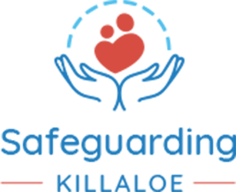

GUEST SPEAKERS.
Kevin Hyland. O.B.E
Kevin is currently CEO of Child Fund Ireland. He is a renowned international specialist in the fight against modern slavery and human trafficking. His expertise has been shaped by 30 years’ experience as an officer in London’s Metropolitan Police Service, notably, as head of the Human Trafficking Unit.
In 2014, Kevin was appointed as the UK’s Independent Anti-Slavery Commissioner by Theresa May, serving with distinction, before stepping down recently to undertake his new role with Child Fund. In 2015, Kevin was appointed Officer of the Order of the British Empire (O.B.E.), acknowledging his outstanding service in combating human trafficking.

Dr. Maureen Griffin.
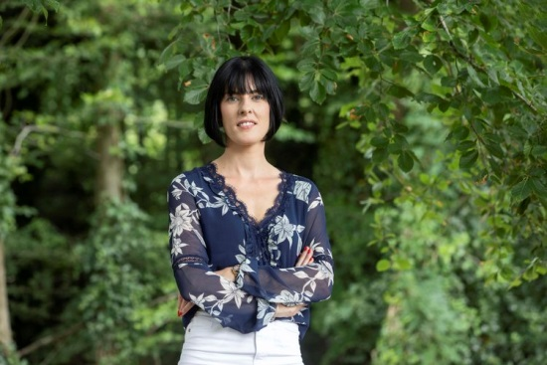

Dr. Maureen Griffin, B.A., M.A., Ph.D. holds an honours degree in Applied Psychology, a Masters in Forensic Psychology and a Ph.D. in Applied (Forensic) Psychology (specifically in the area of Sex Offender Assessment).
Maureen has visited over 700 schools (primary & post primary) across Ireland speaking with students, staff, BOM members and parents regarding issues around social media, cyber-bullying and internet and mobile phone safety.
Maureen’s primary research interests are in the area of hebephilic sexual offenders, specifically focusing on the role of the Internet in the online solicitation of minors and the utility of implicit measurement techniques in the risk appraisal of sexual offenders. Maureen has analysed online grooming cases from America, identifying patterns of behaviour and escalation in risk of contact offending. Maureen has also worked with offenders in Irish prisons testing the efficacy of implicit measurement techniques in assessing risk.

