Confirmation
2018
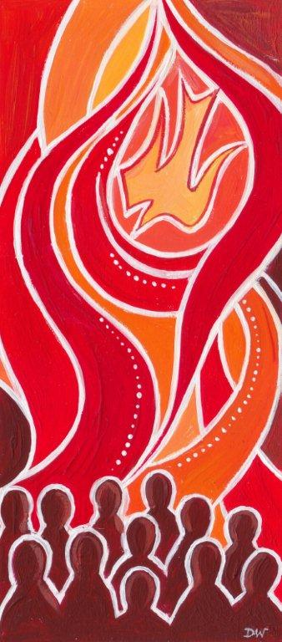

Name of Church

Date & Month 2018

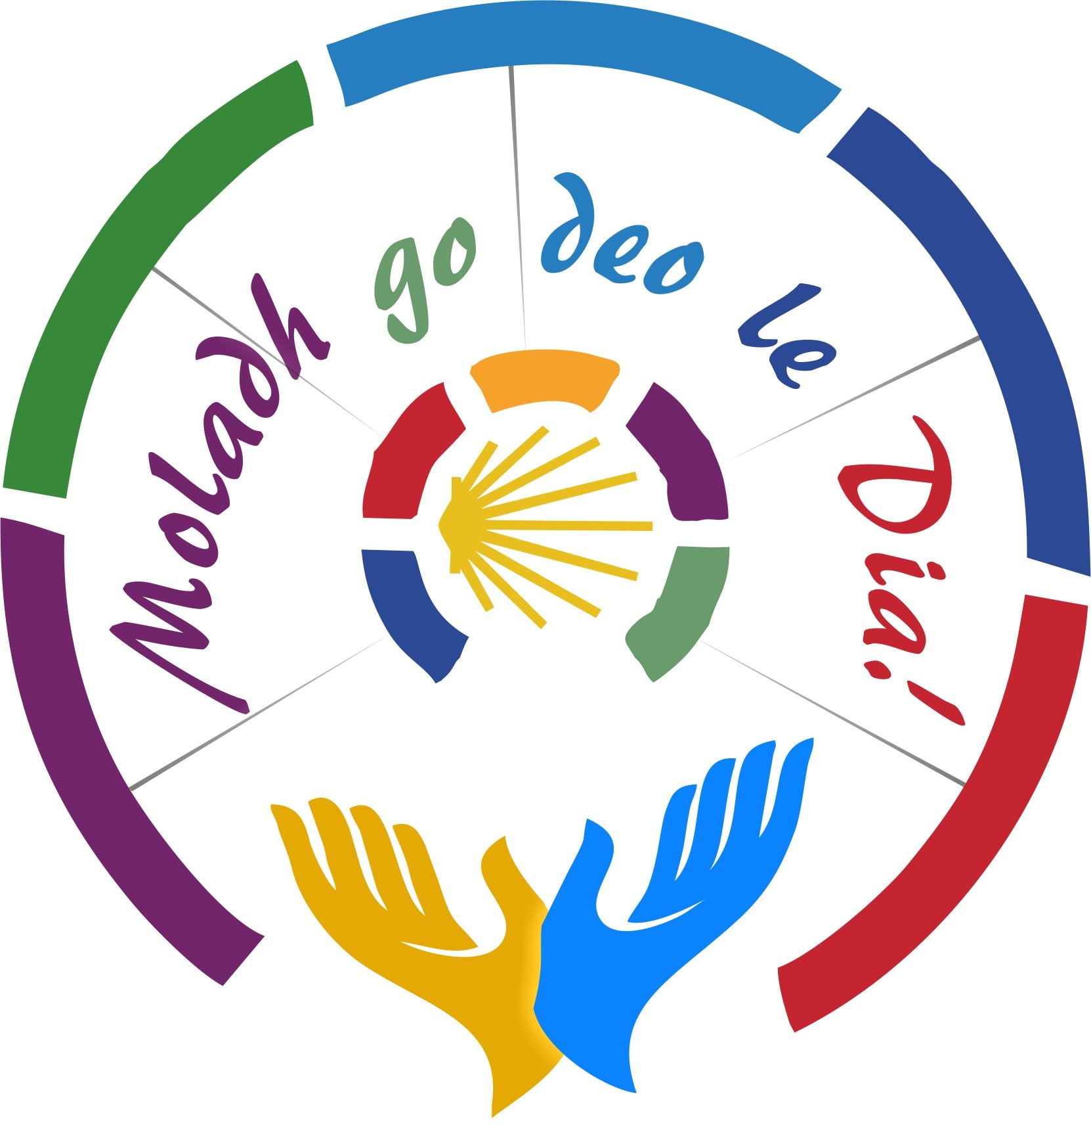
Celebrant:
Bp. Fintan Monahan
Bishop of Killaloe
The Gathering Rite
It is appropriate for a representative of the Parish Community (Chair/Member of the Parish Pastoral Council) to welcome those who have gathered.
They might use these or similar words:

Words of Welcome
On behalf of the faith community in the parish of (Name of Parish), I welcome you all here today as we rejoice in the gifts of the Spirit that are given to us to help build up God’s Kingdom. I warmly welcome Bishop Fintan, the young people who will receive the Sacrament of Confirmation along with their families, friends and visitors who have come to share in this special day on their journey of faith. Today these young people will commit to living the Christian way of life and they will receive the Holy Spirit to help them in that mission. Our parish rejoices as they are confirmed in the faith of their Baptism, the faith of this community, the faith of the Church.

I now invite you to stand for the procession and to join in our Gathering Hymn:
(Name of Opening Hymn here).

Bishop Fintan: In ainm an Athar…
All: Amen
Bishop Fintan Peace be with you
All: And with your Spirit.

Bishop Fintan says some words of welcome and then invites everyone to sit for the Procession of Symbols.

The Procession of Symbols

Reader(s):

We celebrate the sacrament of confirmation in a special year. In August, a gathering called the World Meeting of Families will be held in Dublin. Pope Francis has personally chosen Dublin for this event and is coming himself. The Pope has written a letter to all families called The Joy of Love to help us prepare for his coming. In the letter Pope Francis speaks about how we are called as families to live the way of love. We know that we cannot live this way without the gifts of the Holy Spirit. Today we ask God’s Spirit to come to help us to live the way of love that Pope Francis speaks about.

- _________ brings the Letter of Pope Francis, The Joy of Love, to the altar. In this letter, Pope Francis encourages and inspires us to live the way of love like Jesus. (The Letter of Pope Francis is placed in the Sacred Space)

- __________ brings a circle of family, a symbol representing each family here today whatever form it takes. Family is the place where we learn to live with others. It’s where we first come to know love, where we grow, where we learn to belong, to forgive and to be forgiven. (Place the Circle of Family in the Sacred Space).

- _________ presents the Bible/ the book of the Gospel. Pope Francis says that this book is full of stories about families: births, love stories and stories about times when things go wrong in families. The Word of God, he says, offers words of comfort to encourage us as families. (Place Bible/Book of the Gospels in Sacred Space).

- Pope Francis says that we show love in our families when we use “three essential words”: ‘Please’, ‘Thank You’ and ‘Sorry’. “Let us not be stingy about using these words’, Pope Francis says. ______, ______, and ______ now bring these words to the Altar. We ask God’s Spirit to give us generous hearts so that we will use these words often. (The three words are placed in the Sacred Space).

5 __________ brings the Candle of Hope to the Altar. At one time or another every family faces times of difficulty or struggle. Pope Francis prays that families ‘may never lose heart’ at times like this. Often it is the love of family and friends which keeps hope alive in us when things are difficult. We remember those who support us as a family as we bring this candle. (Place the Candle of Hope in the Sacred Space).

- The Candle of Faith is brought by __________. In his letter, Pope Francis tells us that ‘Faith is God’s gift, received in baptism… parents are the means God uses to help our faith to grow and develop”. We thank God today for all who have helped us to grow in faith, our parents and families, our teachers, our parish communities, our sponsors and God-parents. (Place the Candle of Faith in the Sacred Space).

- Pope Francis asks us to be families ‘with big hearts’. __________ brings a poster / photograph / Trócaire box / display of a charity which our class visited / raised money for this year. This reminds us of families who may be hungry, homeless, have no health care or no way of earning money. This is not the world as God wants it to be. Today we remember that we are called to reach out beyond our own family to help others. (Place symbol in the Sacred Space).

- We bring football/ musical instruments / art pieces to the altar. We celebrate all our gifts and talents and creativity. May our use of these gifts make the world a better place, and help build up our families and communities. (Place the symbols in the Sacred Space).

- We witness that we are followers of Jesus when we try to make the world a better place. ___________ presents the log of all the acts of random kindness done by the Confirmation class(es) in the past few months. These will be added to the giant log which will be presented to Pope Francis at the World Meeting of Families. (Place symbol/symbols in Sacred Space).

- ___________ brings the oil of chrism to the altar with which each candidate will be anointed here today in the sacrament of confirmation. We pray that with this anointing, the fire of God’s Spirit will come upon us so that we will be able to live the way of love in our families and community.

- Finally, the special Icon of the World Meeting of Families is brought to the altar by __________. In the centre of the icon is the Holy Family of Jesus, Mary and Joseph. They are a family just like ours. They have known times of worry and sadness. They have had to run from danger into a strange land. In the icon they are seated at table sharing a meal. They have a place at the table for us and they invite us to join them as we celebrate this special Mass. (The Icon of the Family is placed in the Sacred Space).

Penitential Rite:

Bishop Fintan:
Pope Francis says that families come in all sorts of shapes and sizes and no family is perfect or ideal. Only God can love completely and totally. So we ask God’s forgiveness for the times when we have not shown love.

Bishop Fintan: Lord Jesus, your Spirit is patience and gentleness.
Lord, have mercy.
All: Lord, have mercy.

Bishop Fintan: Christ Jesus, your Spirit is tenderness and love. Christ, have mercy.
All: Christ, have mercy.

Bishop Fintan: Lord Jesus, your Spirit is kindness and peace.
Lord, have mercy.
All: Lord, have mercy.

Bishop Fintan: May almighty God have mercy on us,
forgive us our sins and bring us to life everlasting.
All: Amen

Gloria:
Glory to God in the highest,
and on earth peace to people of good will.

We praise you, we bless you, we adore you, we glorify you.
We give you thanks for your great glory.
Lord God, heavenly King,
O God, almighty Father.

Lord Jesus Christ, Only Begotten Son,
Lord God, Lamb of God, Son of the Father,
You take away the sins of the world, have mercy on us.
You take away the sins of the world, receive our prayer.
You are seated at the right hand of the Father, have mercy on us.

For you alone are the Holy One, you alone are the Lord,
You alone are the Most High, Jesus Christ,
with the Holy Spirit, in the glory of God the Father. Amen.

Opening Prayer:

Bishop Fintan: Let us pray.

Lord, send your Holy Spirit
to make us witnesses before the world
to the good news proclaimed by Jesus, your Son.
We ask this through Christ the Lord.

All: Amen.

The Liturgy of the Word: (Congregation sits)

First Reading
A reading from the prophet Isaiah (61:1-3)
(Pause)
The spirit of the Lord has been given to me,
for the Lord has anointed me.
He has sent me to bring good news to the poor,
to bind up hearts that are broken;
to proclaim liberty to captives,
freedom to those in prison;
to proclaim a year of favour from the Lord,
a day of vengeance for our God,
to comfort all those who mourn
and to give them
for ashes – a garland
for a mourning robe – the oil of gladness,
for despondency, praise.
Pause

The Word of the Lord

All: Thanks be to God

Psalm

Second Reading: (1 Cor 13: 2-3)
A Reading from the Letter of St Paul to the Community in Corinth

If I give all I possess to the poor, but do not have love, I gain nothing.
Love is patient, love is kind.
It does not envy, it does not boast, it is not proud.
It does not dishonour others, it is not self-seeking,
it is not easily angered, it keeps no record of wrongs.
Love does not delight in evil but rejoices with the truth.
It always protects, always trusts, always hopes, always perseveres.
Love never fails.

Pause

The Word of the Lord
All: Thanks be to God

Gospel Acclamation: (All stand)
Sing: Alleluia, Alleluia, Alleluia
All say: Come, Holy Spirit,
fill the hearts of your faithful,
and kindle in them, the fire of love.
Sing: Alleluia, Alleluia, Alleluia

Bishop Fintan: The Lord be with you
All: And with your Spirit.

Bishop Fintan: A reading from the Gospel of St John
All: Glory to you, O Lord.

Gospel: (John 14: 15-17)
A reading from the Holy Gospel according to John

Jesus said to his disciples:
'If you love me you will keep my commandments.
I shall ask the Father,
and he will give you another Advocate
to be with you for ever,
that Spirit of truth
whom the world can never receive
since it neither sees nor knows him;
but you know him,
because he is with you, he is in you.’

The Gospel of the Lord.

All: Praise to you, Lord Jesus Christ. (All sit)

Presentation of the Candidates

Priest: Bishop Fintan, on behalf of our parish, I ask you to confer the Sacrament of Confirmation on the candidates for confirmation from our schools (name schools).
As their names are called out, each candidate stands.

Bishop Fintan’s homily follows.

The Profession of Faith

The candidates for confirmation are invited to stand.

Bp. Fintan: Dear People of God, dear young people who will confirmed, in the Christian vision, from the earliest days of the Church, Christians have proclaimed their faith in God, the Father, the Son and the Holy Spirit, and have committed themselves to living the way of Jesus. Today, in the presence of your parents and teachers, I ask you to proclaim your faith in God, and to commit yourselves to be followers of Jesus.

Do you believe in God, the Father, who chose each of us to be his sons and daughters?
Candidates: I do.

Bishop: Do you believe in Jesus Christ, who came so that we might have life to the full?
Candidates: I do.

Bishop: Do you believe in the Holy Spirit, the Spirit of Wisdom and Understanding, who guides all who follow the way of Jesus?
Candidates: I do.

Bishop: Do you believe in the community of the disciples of Jesus, the Church?
Candidates: I do.

Bishop: As followers of Jesus, we are called to witness to the faith we speak by the way we live. So now I ask you to renew your commitment to living as followers of Jesus. (The response is: ‘With God’s help I will.’)

Bishop: Will you do all you can to live the way of love that Jesus shows us?
Candidates: With God’s help, I will.

Bishop: Will you turn to God and ask his help in prayer?
Candidates: With God’s help, I will.

Bishop: Will you do your best to respect the dignity of every
person, young and old?
Candidates: With God’s help, I will.

Bishop: Will you make every effort to do good, to show concern for others?
Candidates: With God’s help, I will.

Bishop: Will you do all you can to forgive when others hurt you
or let you down?
Candidates: With God’s help, I will.

Bishop: Will you speak up for the truth and work for fairness
and equality?
Candidates: With God’s help, I will.

Bishop: Will you work to overcome selfishness in your life?
Candidates: With God’s help, I will.

Bishop: Will you work to overcome any envy or resentment in your heart?
Candidates: With God’s help, I will.

Bishop: Will you do your best to be generous, especially to those in need?
Candidates: With God’s help, I will.

Bishop: May the Holy Spirit who has inspired these good things in your heart, fill you with love. May that Spirit guide and strengthen you, and teach you always how to live the way of Jesus. Amen.

Hymn: A hymn to the Holy Spirit is sung.
Veni, Come Holy Spirit by Ian Callinan is very suitable.

The Laying on of Hands: (Candidates kneel)

Bishop Fintan invites sponsors to place their right hand on the shoulder of the candidates. The Congregation may also be invited to stand and pray that the Holy Spirit will come upon the young people to be confirmed. The Bishop and priests present extend their hands over the candidates.

Bishop Fintan: My dear friends, in baptism,
God our Father gave the new birth of eternal life to His chosen sons and daughters. Let us pray to our Father that He will pour out the Holy Spirit to strengthen His sons and daughters with His gifts, and anoint them to be more like Christ the Son of God.

All pray in silence for a short time. Then Bishop Fintan continues:

All powerful God, Father of our Lord Jesus Christ
by water and the Holy Spirit,
You freed your sons and daughters from sin
and gave them new life.
Send your Holy Spirit upon them
to be their helper and guide.
Give them the Spirit of Wisdom and Understanding,
the Spirit of Right Judgement and Courage,
the Spirit of Knowledge and Reverence.
Fill them with the Spirit of Wonder
and Awe in your presence.
We ask this through Christ our Lord, Amen.
All: Amen

Anointing with Chrism

Each candidate to be confirmed comes forward with their sponsor, who places their right hand on the candidate’s shoulder. The Bishop makes the Sign of the Cross on the forehead of each candidate with Chrism and says:

Bishop: N., be sealed with the gift of the Holy Spirit.

Candidate: Amen

Bishop: Peace be with you.

Candidate: And with your spirit.

During the Anointing with Chrism the Choir sings appropriate songs to the Holy Spirit.

The Prayer of the Faithful:

Bishop: Loving God, we bring our prayers to you knowing that you will always listen to what we ask with faith.

Reader: That the Spirit may help us to grow in love, especially in our families. Lord, hear us.
All: Lord, graciously hear us.

Reader: That the Spirit may teach us to be people who understand, forgive and accept others.
Lord, hear us.
All: Lord graciously hear us.

Reader: That we may learn generosity to others,
especially those who are less well off than we are.
Lord, hear us.
All: Lord graciously hear us.

Reader: That we may learn how be open to other people, especially those who are different from us. May the Spirit teach us to see the dignity of every person. Lord, hear us.
All: Lord graciously hear us.

Reader: That we may learn how to cope when things don’t turn out as we wish. Send your Spirit to help us at times of disappointment. Lord hear us.
All: Lord graciously hear us.

Reader: That we may learn how to make good decisions in our lives. May the Holy Spirit give us wisdom to make good choices. Lord hear us.
All: Lord graciously hear us.

Reader: That we may be able to stand up for what is true and just. May the Holy Spirit give us strength and courage when we need it. Lord hear us.
All: Lord graciously hear us.

Reader: As this time of joy and celebration for us, we pray especially for families who are suffering because of sickness, unemployment or other difficulties at home.
We pause to remember any family or situation which needs our prayer. Lord hear us.
All: Lord graciously hear us.

Bishop: (If there is a special Church feast-day, a prayer may be added here to reflect the feast).

Bishop: Lord, send your Spirit upon us and on these young people who have been confirmed today so that all of us may come to know your love and the power of your Spirit in our lives. We make this prayer in Jesus’ name. Amen.

The Liturgy of the Eucharist

Procession and Preparation of the Gifts
(The gifts of bread and wine are now brought to the altar while instrumental music or an appropriate hymn is sung. This is a very appropriate place for instrumental music.)

The Eucharistic Prayer

Bishop Fintan: The Lord be with you.

All: And with your Spirit.

Bishop: Lift up your hearts.

All: We lift them up to the Lord.

Bishop: Let us give thanks to the Lord our God.

All: It is right and just.

All sing: Holy, Holy….

All sing: We proclaim your Death, O Lord
and profess your Resurrection,
until you come again.

All sing: Amen.

The Lord’s Prayer: (All stand)

Communion Rite.
Eat this bread, drink this cup,
Come to me and never be hungry;
Eat this bread, drink this cup,
Trust in me and you will not thirst.
(Taizé Chant)

Post Communion Reflection

Hymn for the World Meeting of Families

All sing: The joy, of love, a joy for all God’s family,
The joy of love transcending time and space.
Our Love for each other mirrors God the Father’s love.
The joy of love: a joy for all the earth.

Reader 1: Love bears all things, endures all things
Love longs for all things good, love never ends
Love is patient, and love is kind.
Love is not resentful; it is not rude.
Love is not arrogant, nor boastful, nor jealous,
but love rejoices, rejoices in the truth.

All sing: The joy, of love, a joy for all God’s family,
The joy of love transcending time and space.
Our Love for each other mirrors God the Father’s love.
The joy of love: a joy for all the earth.

Reader 2: Here in Gods family all find their home.
All can find salvation, troubled souls find peace.
Here is found tenderness, compassion and justice
Here God reaches down to us and touches us with grace.

All sing: The joy, of love, a joy for all God’s family,
The joy of love transcending time and space.
Our Love for each other mirrors God the Father’s love.
The joy of love: a joy for all the earth.

Reader 3: This is what God asks of us, to act with justice,
to love with tenderness, to walk humbly with God,
to give our lives in service to others.
The joy of the Gospel is the joyful love of Christ!

All sing: The joy, of love, a joy for all God’s family,
The joy of love transcending time and space.
Our Love for each other mirrors God the Father’s love.
The joy of love: a joy for all the earth.

Concluding Prayer

Bishop Fintan: Let us pray…
Lord, help those you have anointed by your Spirit,
and fed with the body and blood of your Son.
Support them through every trial and by their works of
love build up the Church in holiness and joy.
Grant this through Christ our Lord.

All: Amen.

Final Blessing and Dismissal:

Bishop Fintan: The Lord be with you.
All: And with your Spirit.

Bishop: God our Father made you His children by water and the Holy Spirit, may He bless you and watch over you with His fatherly love.
All: Amen.

Bishop: Jesus Christ, the Son of God promised that the Spirit of truth would be with His Church for ever, may He bless you and give you courage in professing the true faith.
All: Amen.

Bishop: The Holy Spirit came down upon the disciples and set their hearts on fire with love. May He bless you, keep you one in faith and love, and bring you to the joy of God’s Kingdom.

Bishop: May almighty God bless you,
the Father and the Son and the Holy Spirit.

All: Amen.

Bishop: Go in peace, glorifying the Lord by your life.
All: Thanks be to God.
Final Hymn

Sing Alleluia (outside of Lent only) (Stand and Sing)

Refrain: Sing, sing, sing alleluia!
This is the day the Lord has made.
Dance, dance, dance alleluia!
This is the day the Lord has made.

Let us rejoice and be glad,
This is the day the Lord has made,
Let us rejoice and be glad,
This is the day… Repeat Refrain.

Play music to honour God’s name,
This is the day the Lord has made,
Sing songs, and songs of praise,
This is the day… Repeat Refrain.



