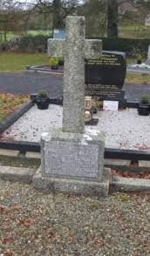

**Prayer for the Peoples’ Blessing of Graves**

In our tradition, the blessing of graves in November is an important ritual as we remember our dead. Due to the present COVID restrictions, we cannot celebrate the blessing of graves in the usual way as a community. We can, however, visit the graves of family and loved ones ourselves and as families. We are encouraged to bring along holy water which has already been blessed and bless the grave of our loved ones ourselves.

“What is a blessing? A blessing is a circle of light drawn around a person to protect, heal and strengthen… It is a gracious invocation where the human heart pleads with the Divine heart”. ( John O’ Donohue.)

This prayer may help us to find words to pray as we bless the grave.

God of all creation,

You are present in every place,

in every moment of history,

you are with us, here and now.

We believe that those we loved

who are buried in this grave *(speak their names)*

are held in your embrace.

As we sprinkle this water, *(sprinkle holy water)*

we pray that a circle of light, happiness and peace

may surround them and that they may come

to the fullness of life in your presence.

We remember how their lives shaped us,

their hands held us, their words inspired us,

their love supported and sustained us.

Eternal God, you see face to face

those we remember here.

Give us confidence that what we have loved in them

is not lost, but lives on in your presence,

as it does in our hearts.

Comfort us in our loss and help us to believe

that one day we shall be united with them

when we too shall see you, face to face.

We ask this in the name of Jesus, your Son,

the first-born from the dead,

who lives and reigns with you forever and ever. Amen