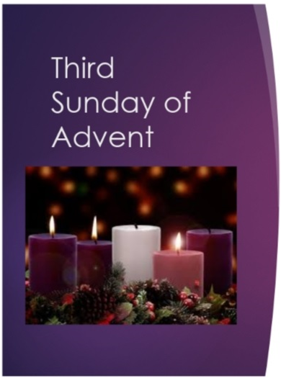

**Lighting of the 3rd Candle on the Advent Wreath**

The Priest makes the Sign of the Cross and greets the people

**Priest** “Rejoice in the Lord always,

again I say ‘rejoice!’ The Lord is near.”

Today, is called Gaudate Sunday,

or rejoicing Sunday.

We rejoice because the Lord is near.

He comes bringing what our hearts long for, bringing freedom to those over burdened,

bringing hope to those despairing,

bringing comfort to those who mourn.

We open our hearts to receive him

as we light this candle of joy,

knowing that we are not alone,

not abandoned, not lost,

but that God is very near.

(The 3rd candle is now lit on the Advent wreath.)

Lord have mercy…

Christ have mercy …

Lord have mercy …