Rainer Maria Rilke
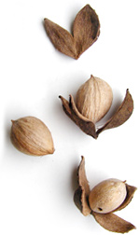
Being an artist means: not numbering and counting, but ripening, like a tree which doesn’t force its sap, and stands confidently in the storms of spring, not afraid that afterward summer may not come. It does come. But it comes only to those who are patient, who are there as if eternity lay before them, so unconcernedly silent and vast. I learn it every day of my life, learn it with pain I am grateful for: patience is everything!
Source: Letters to a Young Poet

