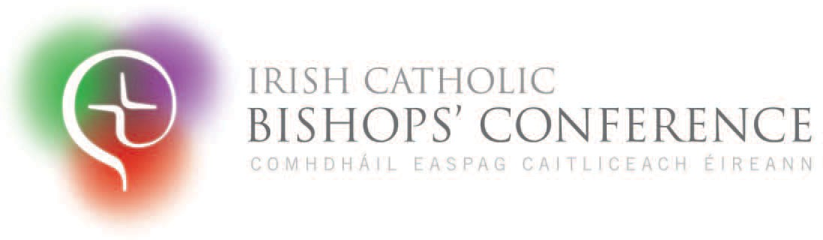
Why Sunday Matters
An invitation to reﬂect on Sunday Mass

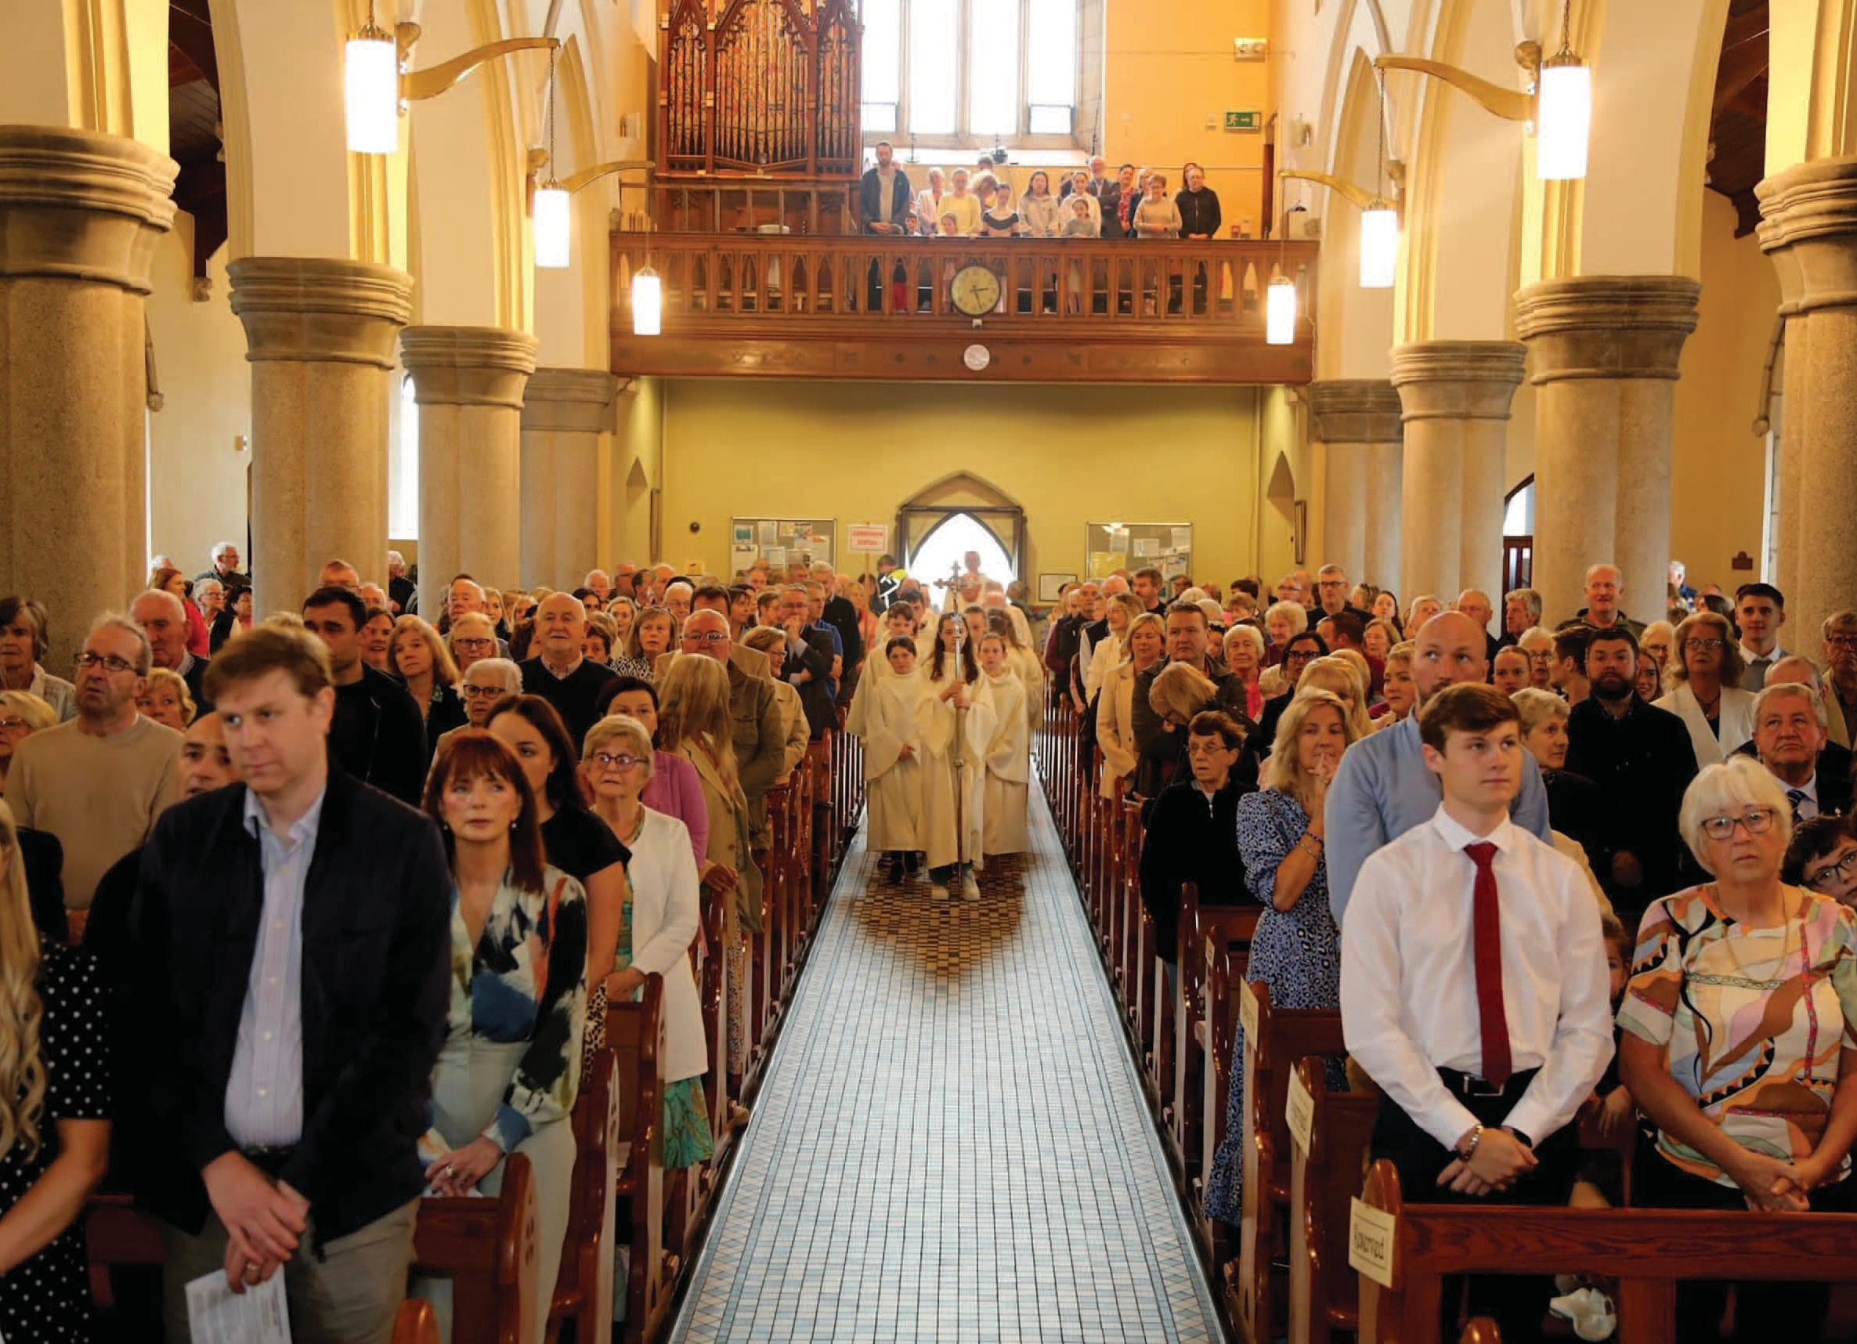
s we journey through this Jubilee Year of Hope, we, the Irish Bishops, warmly invite all Catholics to reﬂect on the
Photo: John Bradley
A
immense signiﬁcance of Sunday Mass and, for those who have not yet done so, to return with renewed joy to the celebration of the Eucharist.
Sunday has always been the day of the Lord: the day of resurrection, the day of rest, the day of Eucharist. From the very beginning of our Christian faith, Sunday has been central to the

life of the Church and remains the heart of Christian practice. It is on this day that we

Sunday Mass, St Clare’s Church, Graiguecullen, Carlow

gather as a community, united in our love for Christ, to encounter the risen Lord and be nourished in body and soul.
The Mass is not just a ritual, it is the source and summit of our faith. It is where we encounter Christ in His living presence, and it is through the Eucharist that we are strengthened to live as true disciples. Attending Mass on Sundays, or its vigil on Saturday evening, is not just an obligation; it is a profound privilege and a chance to experience God’s love in a deeply personal way. As we come to this sacred celebration let us do so with hearts full of gratitude for the precious gi of Christ’s presence among us.


Our invitation to reﬂect on Sunday Mass is presented through the lens of Synodality – Communion, Participation, and Mission – reminding us that the Eucharist is not just a personal encounter with Christ but also a communal experience that unites us all as the People of God. For deeper reﬂection, we have also provided thoughtful questions at the end of this message to guide your prayers and meditations.
How can you enrich
your experience of Mass and make it a central part of your life?
How can young
people best engage in our Sunday celebration?

Why Sunday Matters: Sunday Mass creates and celebrates Communion

Sunday Mass is a vital encounter with the risen Lord, the One who gives our lives ultimate meaning and purpose. Through our baptism we bear the name 'Christian'. This identity shapes who we are and calls us to follow Jesus, who is ‘the way, the truth, and the life’ (John 14:6). Through the celebration of Sunday Mass, we experience a life-giving encounter and communion with Christ.

What does it mean for you to have a real encounter with Jesus in the Mass?
What could it mean?
Just as the two disciples encountered Jesus on the road to Emmaus and recognised Him in the breaking of the bread (Luke 24:35), so too we meet Him in the Eucharist.
Our identity as Christians is not solitary but shared. On Sundays, we gather not only as individuals but as the Church; the Body of Christ. In the celebration of the Eucharist, we aﬃrm our communion with one another and with Christ. Pope Saint John Paul II emphasised that ‘none is as vital or as community-forming as the Sunday celebration of the Lord’s day and His Eucharist.’ This gathering creates a bond of unity, solidarity, and love, as we come together to worship as one body, with one voice, in praise of God.

Why Sunday Matters:
an invitation to Participate

The journey of faith oen comes with its own set of challenges. Many, particularly the younger generation, feel disconnected from the Church due to past abuses and how these were addressed. Alongside this, the pressures of modern life, the increasing levels of anxiety and mental health diﬃculties – especially among young people – together with the lingering eﬀects of the pandemic, have contributed to a sense of

How can the scriptures proclaimed at Mass inspire us to love as Jesus loved?
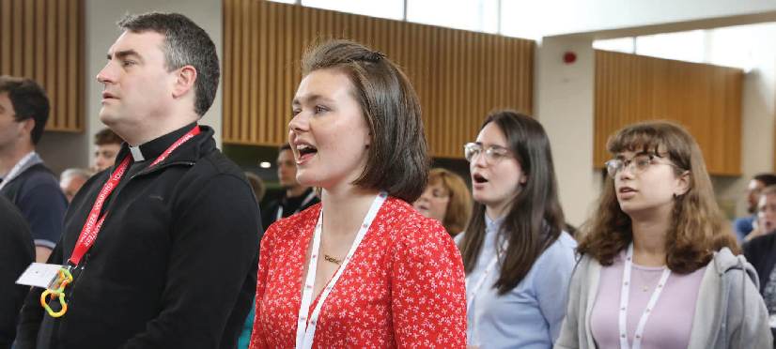
distance from the Church. However, Sunday Eucharist continues to be a source of hope, life, and profound meaning. It invites us to participate in the celebration of Christ’s death and resurrection, the Paschal Mystery. In this sacred celebration, we have the opportunity to be transformed, to receive God’s grace, and to
become the best versions of ourselves. As we navigate life, with all its joys and struggles, the Eucharist oﬀers us the community and support we
Photo: John McElroy

need to ﬂourish and grow in faith.


Why Sunday Matters
Intentional
Young Adult Ministry event, organised by the Bishops’ Conference,
Co Kildare, June 2024.

Mass is not just a personal act of devotion; it is a communal act of worship. We go to God together. The Sunday Mass is where the Church is most visibly alive, and where every member of the community plays an essential role. Each person’s participation is needed for the Church to truly live. It is important to gather physically for Mass, and although technology is helpful, it can never replace the tangible experience of being with the community as we listen to God's word and receive the Body of Christ. We invite you to consider how your presence at Mass can contribute to making the Church visible and alive.
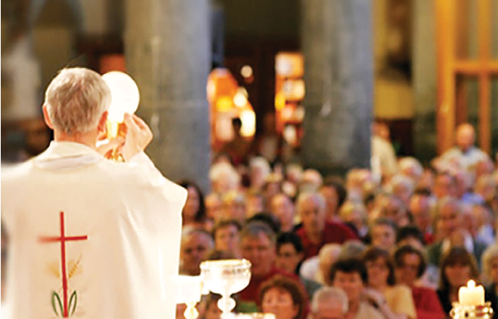
We are deeply thankful to priests and all those who gather to celebrate Mass. Special gratitude goes to those involved in liturgical ministries, such as Ministers of the Word, of Holy Comunion, Music Ministers, Sacristans, and Altar Servers. Encouraging the return of young people as Altar Servers is especially important and should be actively supported by their families and parish. The involvement of young people brings vitality to the liturgy and contributes hugely to their own faith formation.
Photo: Fr John P O’Riordan, Redemptorists, Limerick
Sunday Mass at Mount St Alphonsus Church, Limerick

Why Sunday Matters:
Sunday Mass makes us Missionaries

The Sunday Mass is not only a time for worship but also for mission. Having listened to God’s word and received the gi of Christ’s Body and Blood, we are sent to live out our faith in the world as missionaries; sent to share the love of Christ with others. As we participate in the Sunday Mass, we receive not only spiritual nourishment but also the strength to live out our Christian mission in daily life.

How does your participation in Sunday Mass inspire you to live out your mission as a follower of Christ?
As the late Pope Francis reminded us, ‘We do not go to
Mass in order to give something to God, but to receive what we truly need from Him. In this spirit, we are called to approach the Eucharist not out of obligation, but with a deep desire for spiritual transformation.’ This is why attending Mass on Sundays is so vital – it nurtures and nourishes our faith and prepares us for the mission to which we are called. We invite you to reﬂect on how your participation in Sunday Mass helps you to live as a missionary disciple, bringing the hope and joy of the Gospel to those around you, and to the world at large.

Since the COVID-19 pandemic, many Catholics have faced challenges attending Mass due to health concerns. For those still unable to attend, the Church oﬀers Communion to the sick and housebound. For those who can, it’s time to return and celebrate the Eucharist together. While virtual options have helped, they can’t replace the in-person experience of communal worship.
Returning to Mass strengthens us as the Body of Christ, sharing in the sacred celebration.

Why Sunday Matters

Reﬂecting on our Sunday Mass
Photo: John McElroy

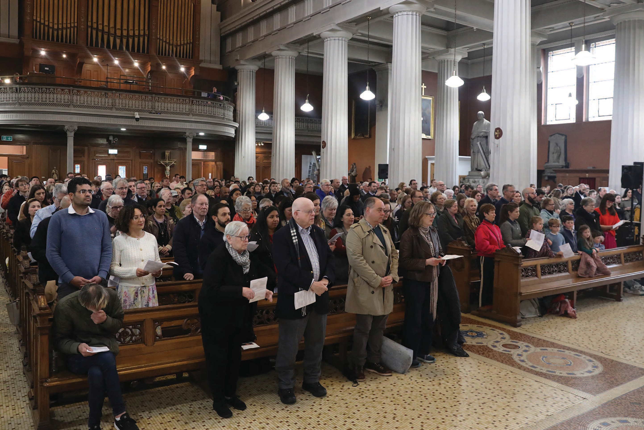
The purpose of this message is to encourage you to reﬂect on what is special about Sunday and what it means to you, and, if you no longer attend, to consider returning to Mass. How can you enrich your experience of Mass and make it a central part of your life?
We invite individuals, families, and parish groups to reﬂect on the following questions and to consider how you can contribute to a more vibrant and welcoming celebration of Sunday Mass in your community.

Easter Sunday Mass in St Mary’s Pro-Cathedral, Dublin 2025

Questions for personal and/or family reﬂection

- How can I enrich my experience of Mass and make it a central part of my life?
- How can I best engage more young people in our celebration?
- Is this message calling me to any change in how I spend my Sunday?
- Who can I share this message and its contents with?

Questions for Parish Leadership, Liturgy Groups, Parish Pastoral Councils and other Ministry Groups
- What makes our Sunday celebration alive? • Why do we think people in our parish go to
Mass, or do not?
- Can we do more to explain and oﬀer
catechesis on the Sunday Mass? • Do visitors feel welcome into our
celebrations? Can we be more social?

- How can we be more welcoming to those who have found it diﬃcult to return to Mass since the pandemic?

- What has been the impact of online Masses on our parish celebration?

- What can we do in our local parish to help bring about a richer celebration of Sunday Mass for all ages?

- Do we need to review Mass times or the number of weekend Masses?


For more information or to download a copy of this document please visit www.catholicbishops.ie
or please email info@catholicbishops.ie


Why Sunday Matters

You are invited to reproduce this content. Please credit the Irish Catholic Bishops’ Conference (2025)

