The Scripture Union Ireland is holding a retreat in Avoca Manor this April 21st.
An invitation to attend has been issued to School Chaplains and R.E. Teachers .
For more details, please see below -

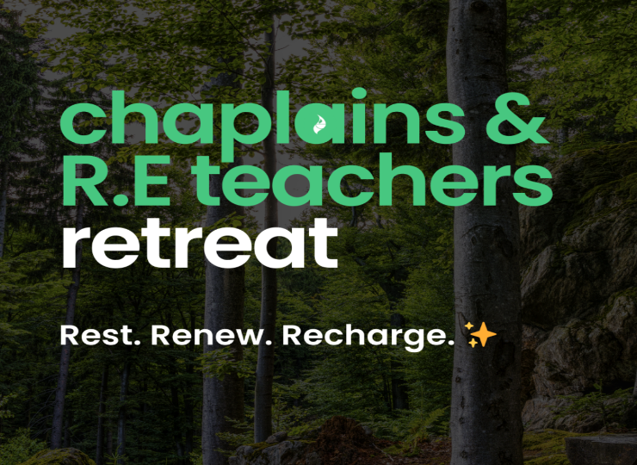

Calling Religion Teachers & School Chaplains 🙌🏽
This retreat aims to provide:
- Personal spiritual development
- Engaging workshops
- Connect with like-minded others
- Support and encouragement
An opportunity to receive instead of giving, a time to ‘recharge the batteries’ and return to your school full of fresh ideas, energy and excitement.
We’d love for you to be part of it.

Sign Up Now

SARAH CAMPBELL
Camps & Schools Coordinator
Scripture Union Ireland
scriptureunion.ie

Registered with the Charities Regulator no.20204664 CHY no.22745 CRO no.595870

